Practical-3

**Aim:-** Implement TWO-WAY *Inter-process communication* using "pipe()" system call between:

1. Child and parent process
2. Two child processes

This communication must continue until a specific key is pressed or any process sends a STOP message.

# Theory:-

Inter-process communication using pipes is a common method for allowing two processes to communicate with each other in a Unix-like operating system. A pipe is a unidirectional communication channel that allows data to ﬂow from one process to another. To establish two-way IPC using pipes, you typically need to create two pipes: one for each direction of communication.

# Code:-

* 1. Child and parent process

#include <stdio.h> #include <stdlib.h> #include <string.h> #include <unistd.h>

#define READ_END 0

#define WRITE_END 1

int main() {

int pipe_fd1[2], pipe_fd2[2]; pid_t child_pid;

char buffer[100]; int bytes_read;

if (pipe(pipe_fd1) == -1 || pipe(pipe_fd2) == -1) { perror("Pipe creation failed"); exit(EXIT_FAILURE);

}

child_pid = fork();

if (child_pid == -1) { perror("Fork failed"); exit(EXIT_FAILURE);

}

if (child_pid == 0) { close(pipe_fd1[READ_END]); close(pipe_fd2[WRITE_END]);

while (1) {

char message[100];

printf("Enter a message for parent: "); fgets(message, sizeof(message), stdin);

write(pipe_fd1[WRITE_END], message, strlen(message) + 1);

bytes_read = read(pipe_fd2[READ_END], buffer, sizeof(buffer)); if (bytes_read <= 0) {

break;

}

if (strcmp(buffer, "STOP\n") == 0) { printf("Communication break !!! \n"); break;

} else {

printf("Received message from parent: %s", buffer);

}

}

close(pipe_fd1[WRITE_END]); close(pipe_fd2[READ_END]); exit(EXIT_SUCCESS);

} else { close(pipe_fd1[WRITE_END]); close(pipe_fd2[READ_END]);

while (1) {

bytes_read = read(pipe_fd1[READ_END], buffer, sizeof(buffer)); if (bytes_read <= 0) {

break;

}

if (strcmp(buffer, "STOP\n") == 0) {

printf("Communication break !!! \n"); break;

} else {

printf("Received message from child: %s", buffer);

}

char message[100];

printf("Enter a message for child: "); fgets(message, sizeof(message), stdin);

write(pipe_fd2[WRITE_END], message, strlen(message) + 1);

if (strcmp(message, "STOP\n") == 0) { printf("Communication break !!! \n"); break;

}

}

close(pipe_fd1[READ_END]); close(pipe_fd2[WRITE_END]);

}

return 0;

}

# Output:-

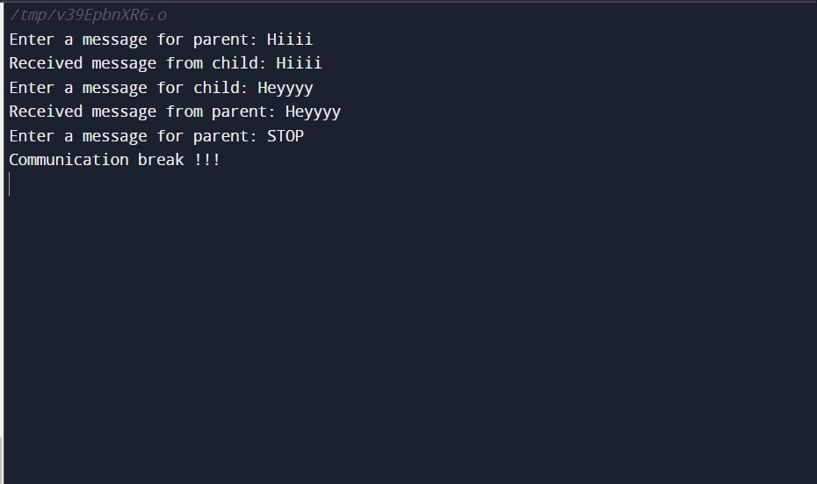

* 1. Two child processes

#include <signal.h> #include <stdbool.h> #include <stdio.h> #include <stdlib.h> #include <string.h> #include <unistd.h>

#define READ_END 0

#define WRITE_END 1

int main() {

int pipe_child1_to_child2[2]; int pipe_child2_to_child1[2]; pid_t child1_pid, child2_pid; char buffer[100];

int bytes_read;

bool stop_communication = false;

if (pipe(pipe_child1_to_child2) == -1 || pipe(pipe_child2_to_child1) == -1) { perror("Pipe creation failed");

exit(EXIT_FAILURE);

}

child1_pid = fork();

if (child1_pid == -1) { perror("Fork failed"); exit(EXIT_FAILURE);

}

if (child1_pid == 0) { // Child process 1 close(pipe_child1_to_child2[READ_END]); close(pipe_child2_to_child1[WRITE_END]);

while (!stop_communication) { char message[100];

printf("Enter a message for Child 2 (or type 'STOP' to end "

"communication): "); fgets(message, sizeof(message), stdin);

write(pipe_child1_to_child2[WRITE_END], message, strlen(message) + 1); if (strcmp(message, "STOP\n") == 0) {

stop_communication = true;

break;

}

bytes_read =

read(pipe_child2_to_child1[READ_END], buffer, sizeof(buffer)); if (bytes_read > 0) {

printf("Message from Child 2: %s", buffer);

}

if (strcmp(buffer, "STOP\n") == 0) { stop_communication = true; printf("Communication break !!! \n"); break;

}

}

close(pipe_child1_to_child2[WRITE_END]); close(pipe_child2_to_child1[READ_END]); exit(EXIT_SUCCESS);

} else { close(pipe_child1_to_child2[WRITE_END]); close(pipe_child2_to_child1[READ_END]);

child2_pid = fork();

if (child2_pid == -1) { perror("Fork failed"); exit(EXIT_FAILURE);

}

if (child2_pid == 0) { // Child process 2 close(pipe_child1_to_child2[WRITE_END]); close(pipe_child2_to_child1[READ_END]);

while (!stop_communication) { char message[100];

bytes_read =

read(pipe_child1_to_child2[READ_END], buffer, sizeof(buffer)); if (bytes_read > 0) {

printf("Message from Child 1: %s", buffer);

}

if (strcmp(buffer, "STOP\n") == 0) { stop_communication = true; printf("Communication break !!! \n"); break;

}

printf("Enter a message for Child 1 (or type 'STOP' to end " "communication): ");

fgets(message, sizeof(message), stdin); write(pipe_child2_to_child1[WRITE_END], message, strlen(message) + 1);

if (strcmp(message, "STOP\n") == 0) { stop_communication = true;

break;

}

}

close(pipe_child1_to_child2[READ_END]); close(pipe_child2_to_child1[WRITE_END]); exit(EXIT_SUCCESS);

} else { // Parent process close(pipe_child1_to_child2[READ_END]); close(pipe_child2_to_child1[WRITE_END]);

wait(NULL); wait(NULL);

close(pipe_child1_to_child2[WRITE_END]); close(pipe_child2_to_child1[READ_END]);

}

}

return 0;

}

# Output:-

